Lab#01
Implementation of basic structure of java programming
environment.
Objective
To get a hands on training exposure to the Java development environment.
Lab Goals
To demonstrate and gain familiarity with the various operations on Sun’s Java development
environment including:
a. Getting knowledge of jdk,jre and jvm.
b. Installing Netbeans 8.2 along with jdk on your PC.
c. Creating a Java Program
d. Saving the program
e. Compiling & debugging
f. Executing the program.
INTRODUCTION TO JAVA
Java is a high-level, object-oriented programming language developed by Sun Microsystems (now owned by Oracle). It is known for its platform independence, meaning Java programs can run on any device that has a Java Virtual Machine (JVM) installed.
INTRODUCTION TO BASIC JAVA ENVIRONMENT:
To write and run Java programs, you need to set up a basic environment consisting of:
1. Java Development Kit (JDK)
2. Integrated Development Environment (IDE) or a text editor
3. Command-line tools (optional)
JAVA DEVELOPMENT KIT
The Java Development Kit (JDK) is a software development environment used for developing Java applications and applets. It includes the Java Runtime Environment (JRE), an interpreter/loader (Java), a compiler (javac), an archiver (jar), a documentation generator (Javadoc) and other tools needed in Java development.
JAVA RUNTIME ENVIRONMENT
JRE stands for “Java Runtime Environment” and may also be written as “Java RTE.” The Java Runtime Environment provides the minimum requirements for executing a Java application; it consists of the Java Virtual Machine (JVM), core classes, and supporting files.


- Notepad
- Notepad++
- IntelliJ IDEA
- Eclipse
- NetBeans
- VS Code
Program:
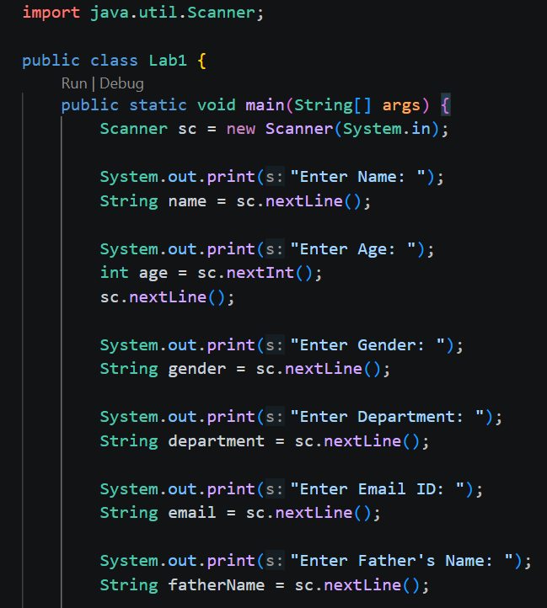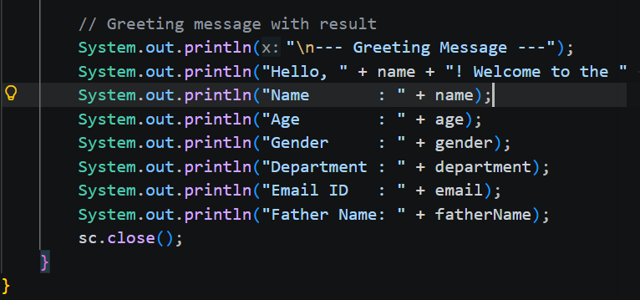
Output:
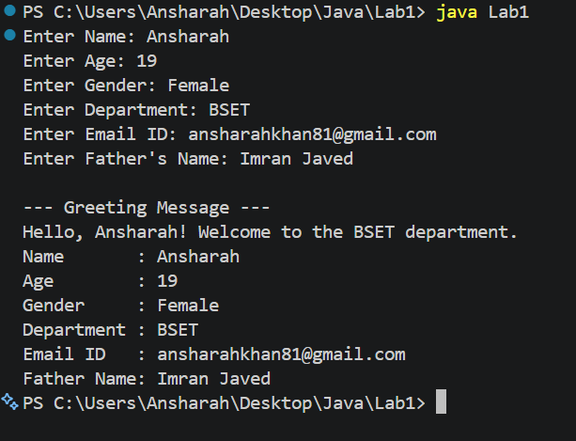

Program:
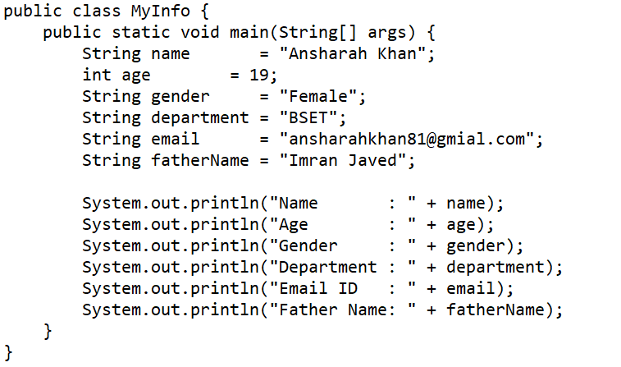
Output:
